Project II - Report

**Team Members:  
  
Sameer Khan  
Ajay Singh**

# Part II: Project Link

Please visit the following link to access the project visualization:

<https://send2asd.github.io/data-visualization/index.html>

# Part III: Explanation of Visualization Components

**1. Zoomable Sunburst:** This visual representation allows users to explore information related to historical events, sites of memory, memory initiatives, organizations, and actors. Users can click through levels, exploring countries, key events, and detailed views of specific years.

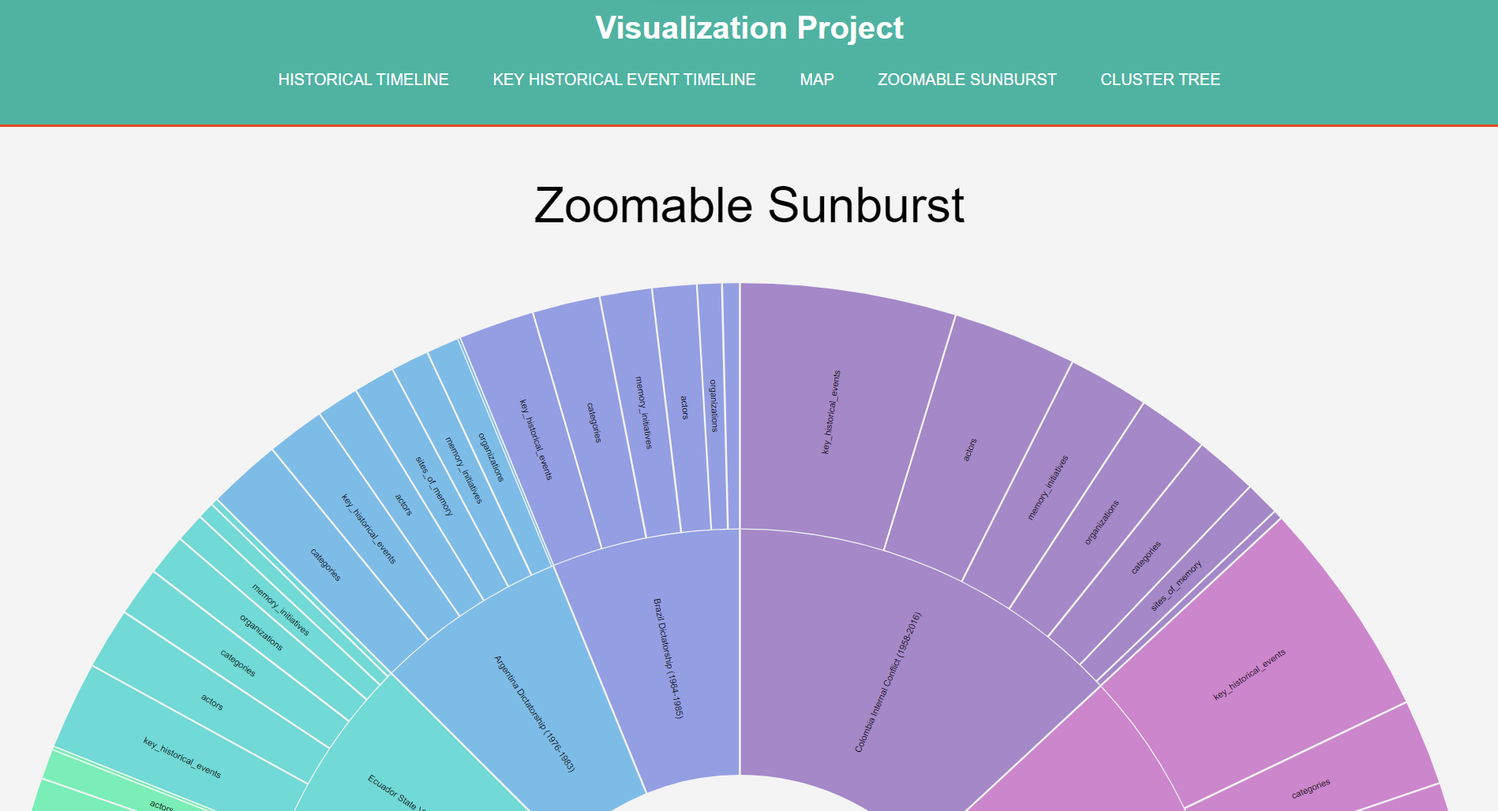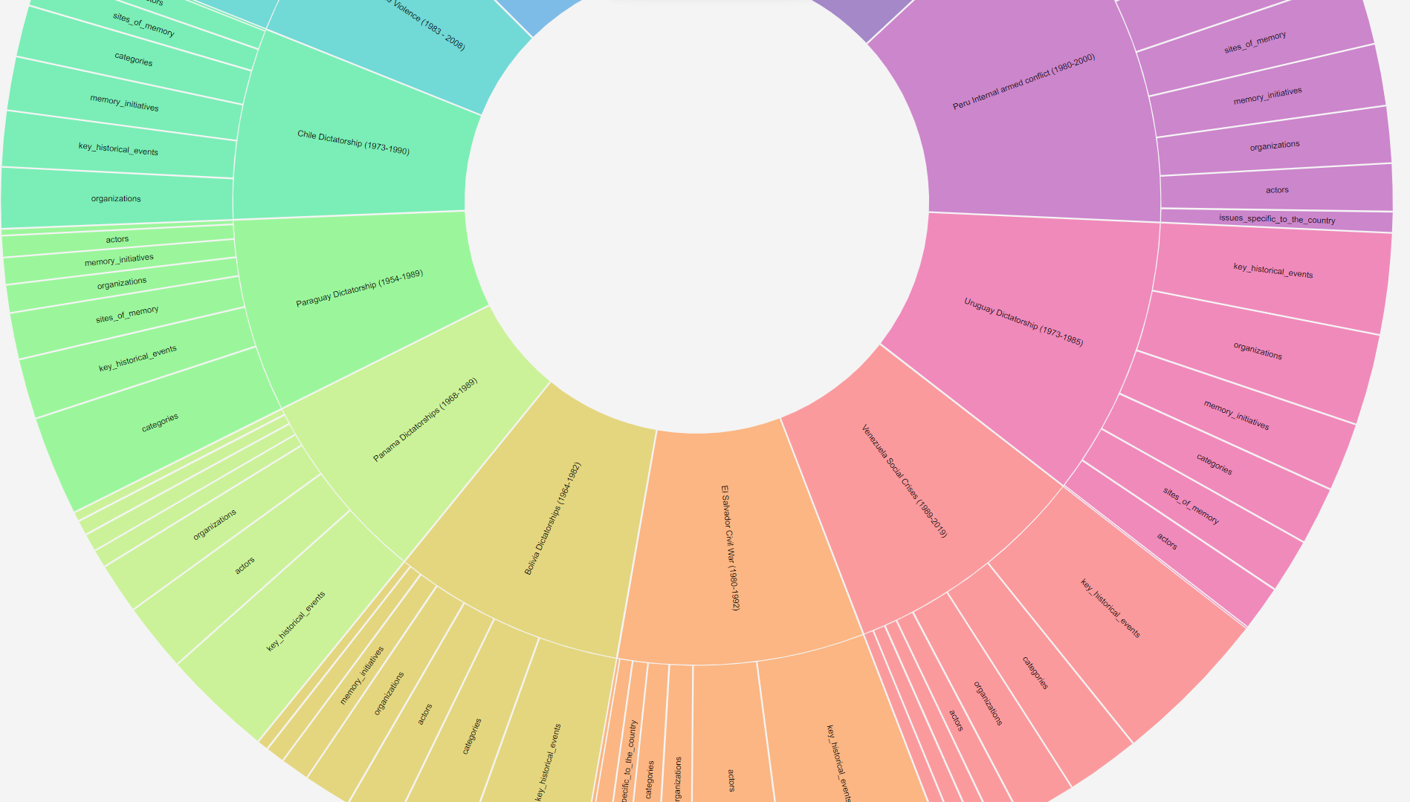  
**2. Timelines:** It providing individual and combined timelines for South American countries, users can view historical events over time. A dropdown menu allows for easy selection of different country timelines.

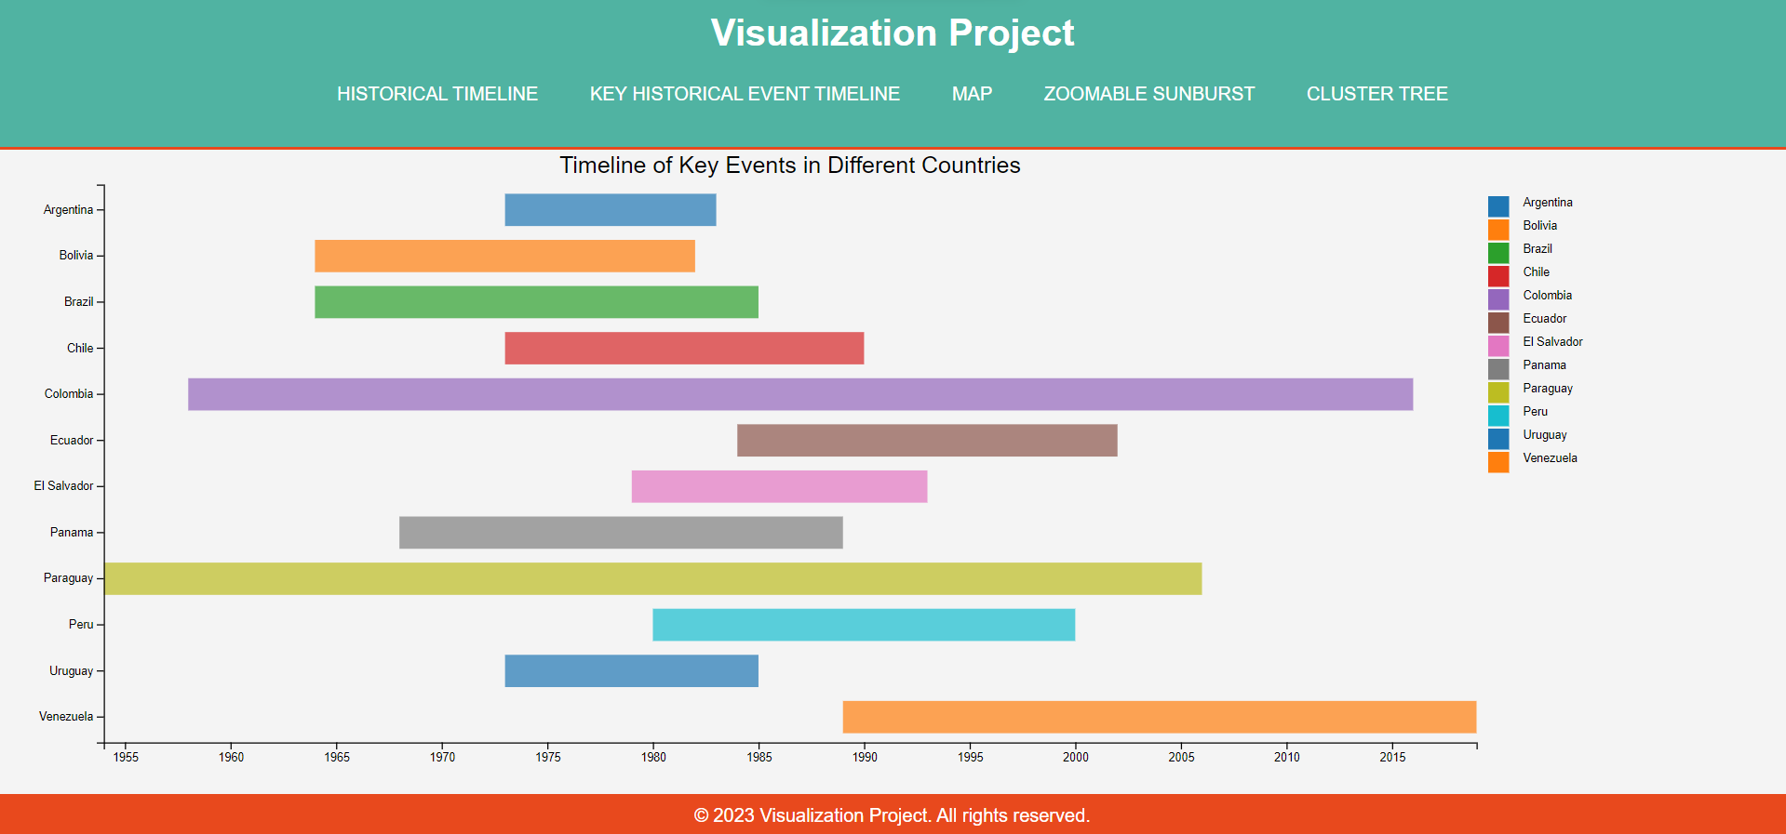

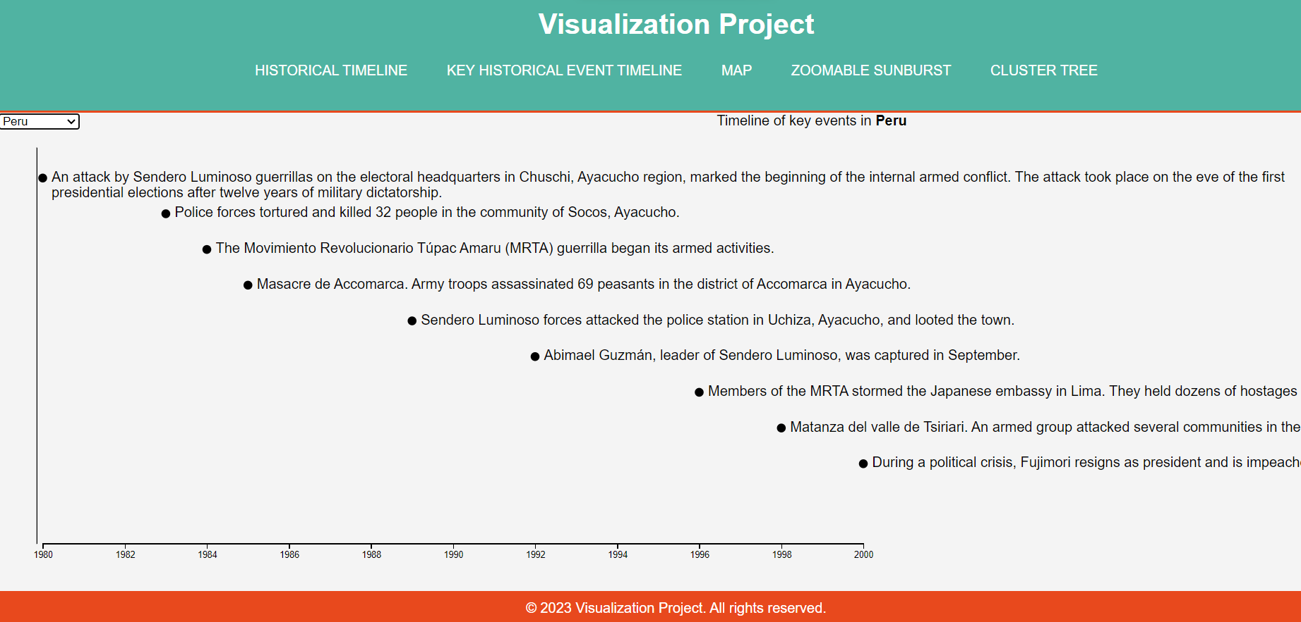

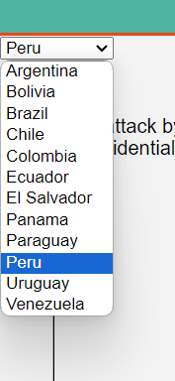

**3. Map with Search Box and Time Range Selection:** This Visualization enables users to explore countries based on a time range and keyword search, highlighting relevant events on the map and allowing for detailed exploration with images for certain events upon clicking on particular Country.

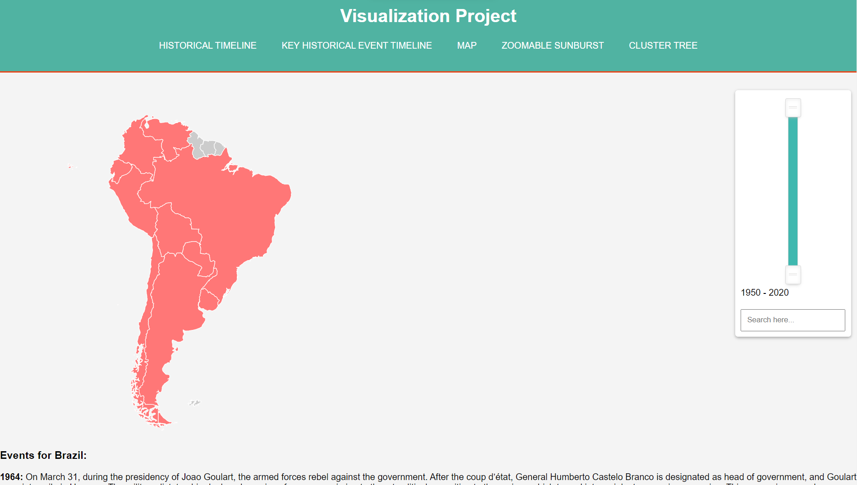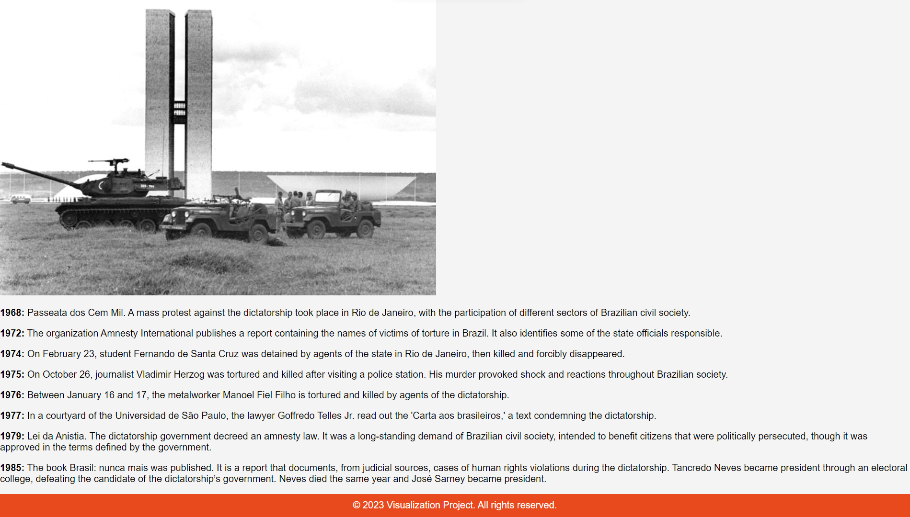

**4. Cluster Tree:** This tree visualization represents entities such as actors, countries, years, organizations, etc. with nodes and links showing details upon clicking on nodes.

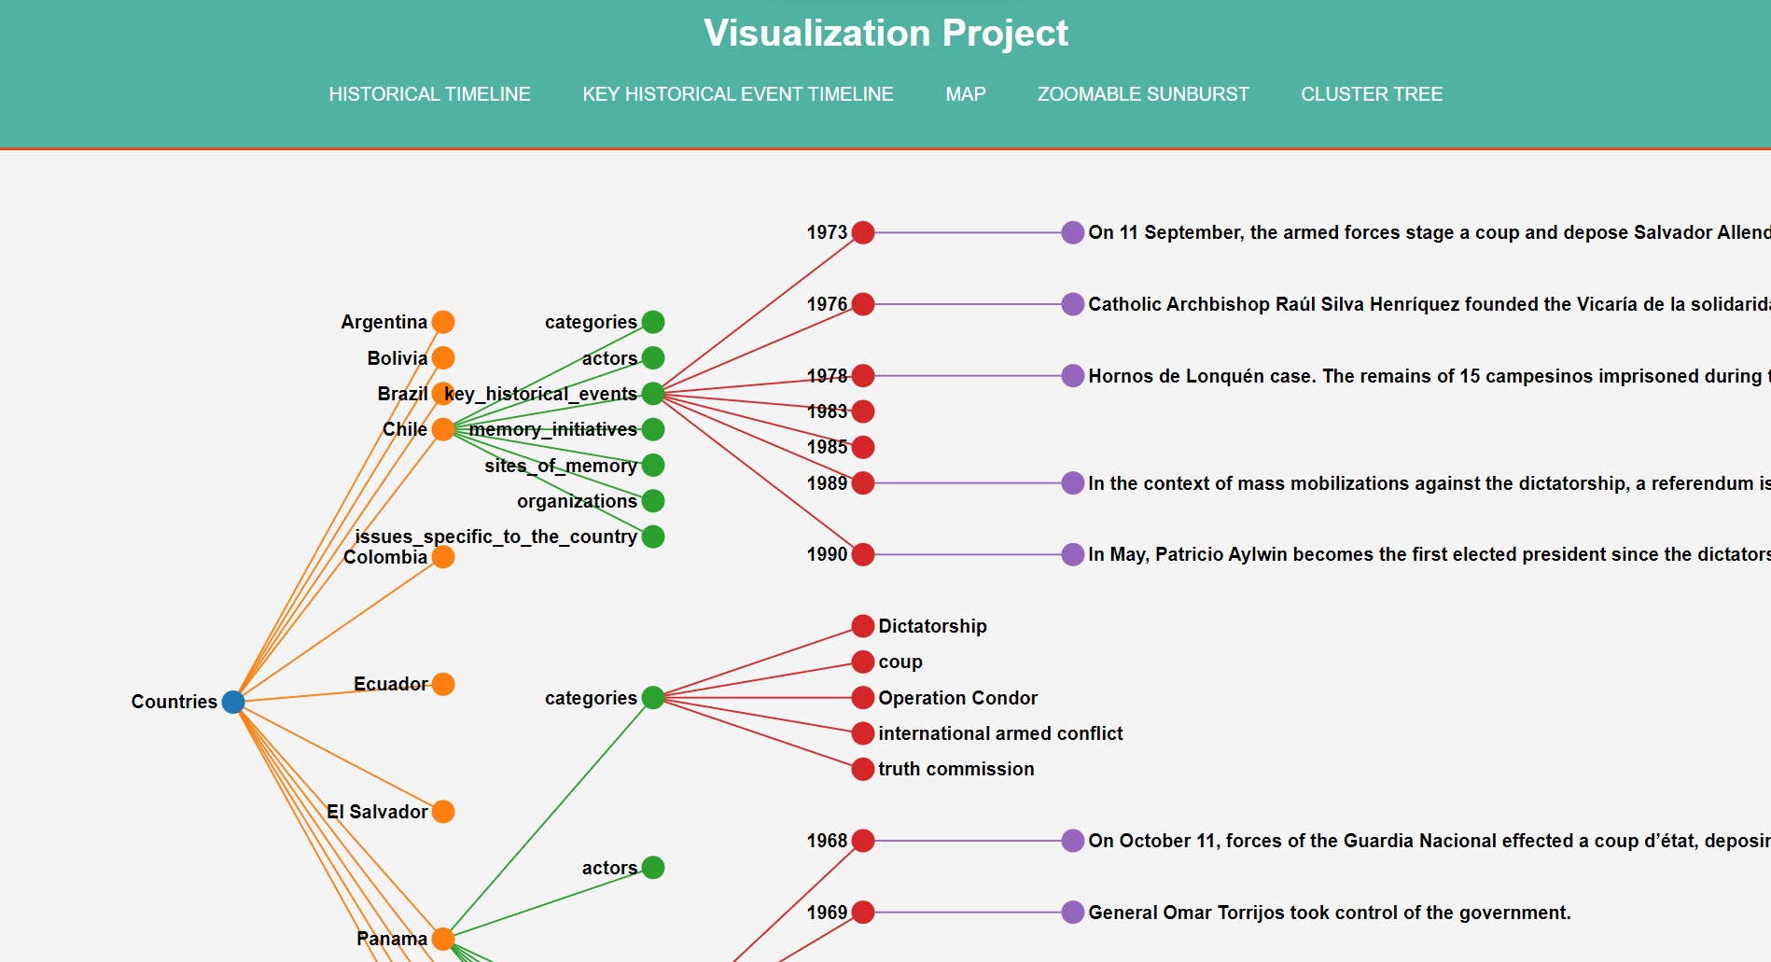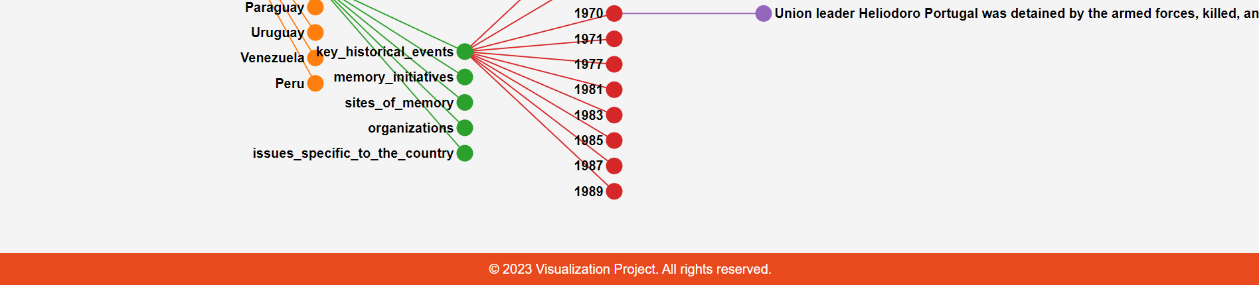

# Part IV: Teamwork and Contribution

Our team communicated effectively throughout the project. We spent about a week on the project, starting with learning about the D3.js library and planning the technology to use in project. We held several meetings at each other's houses, total of approximately 17-20 hours of collaborative work.

- Meeting 1 (2 hours): Learned D3 basics and discussed implementation.  
- Meeting 2 (3-4 hours): Discussed functions for implementation and worked on data conversion to JSON.  
- Meeting 3 (4-5 hours): Divided work; I focused on Zoomable Sunburst and Cluster Tree, while Ajay focused on Timelines and Maps.  
- Meeting 4 (4-5 hours): Worked on Sunburst and Maps and refined the JSON structure.  
- Meeting 5 (2-3 hours): Completed all tasks.  
- Meeting 6 (3 hours): Merged code, finalized UI, and hosted the website on GitHub.  
- Report creation, Part 4 of Reports was created individually.  
  
Task distributions and contributions:  
  
- Zoomable Sunburst: Sameer (90%), Ajay (10%)  
- Timelines: Sameer (10%), Ajay (90%)  
- Cluster Tree: Sameer (100%), Ajay (0%)  
- Map: Sameer (10%), Ajay (90%)  
- Code Merge/UI: Sameer (50%), Ajay (50%)  
- Individual Report: Sameer (100%), Ajay (100%)  
  
Ratings for teamwork:  
  
1. Communication Effectiveness: 10  
2. Priority Setting: 10

The project was a priority for us, and we even took leave from work to ensure its completion.

**Submitted By: Sameer Khan**